8. Student Counselling System
Aim: To develop a simple cloud-based Student Counselling System using Zoho Creator to store student details, academic information, year of passing, percentage of marks and domain interests.
Procedure:
- Create a new application in Zoho Creator named Student Counselling System.
- Create a form with fields such as student name, age, address, phone number, subjects studied, year of passing, percentage of marks and domain interest.
- Add suitable field types and save the form.
- Enter sample student details and submit the form.
- View the submitted student records using the report.
Input & Output:
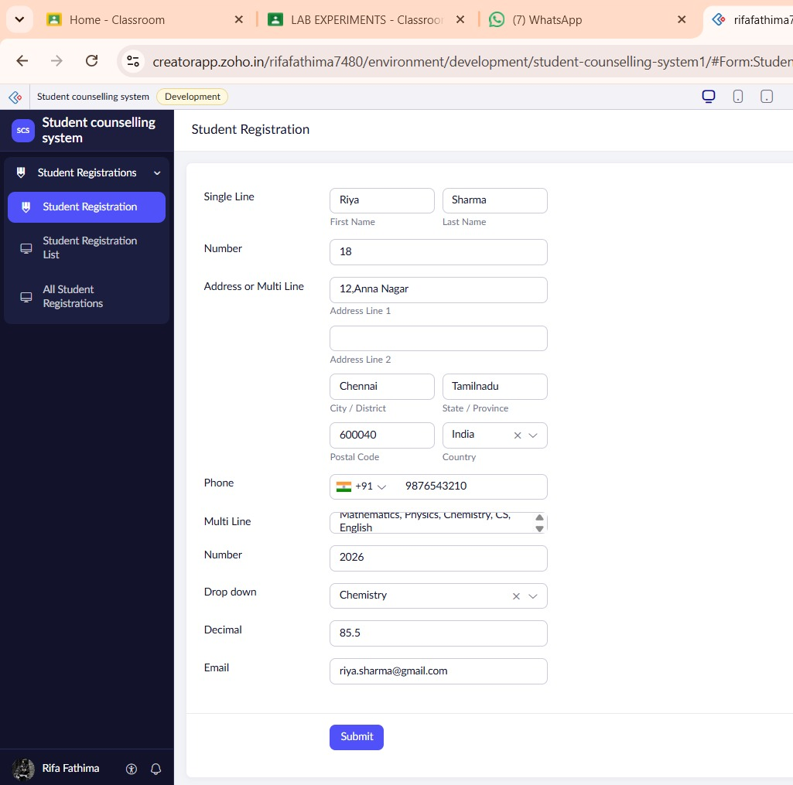
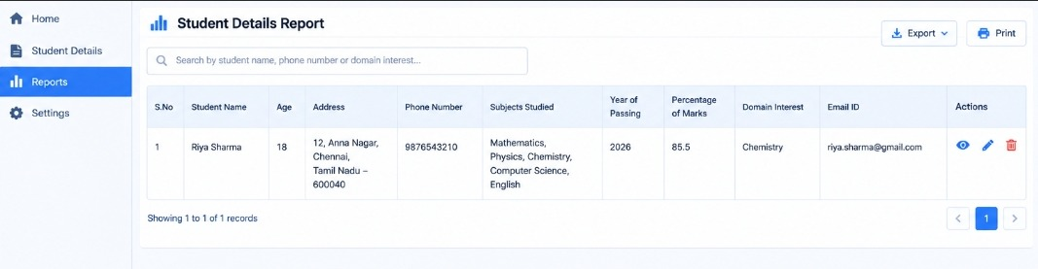
Result: The Student Counselling System was created successfully using Zoho Creator to store and manage student academic details and counselling information through a cloud-based application.

9. Hospital Information System
Aim: To develop a simple cloud-based Hospital Information System for SIMATS Hospital using Zoho Creator to manage patient details, attendant information, doctor details and disease information.
Procedure:
- Create a new application in Zoho Creator named Hospital Information System.
- Create a Patient Information form.
- Add fields such as patient name, age, address, phone number, email, attendant name, attendant phone, doctor name and disease.
- Save the form and enter sample patient information.
- Submit the form and view the saved records in the report.
Input & Output:
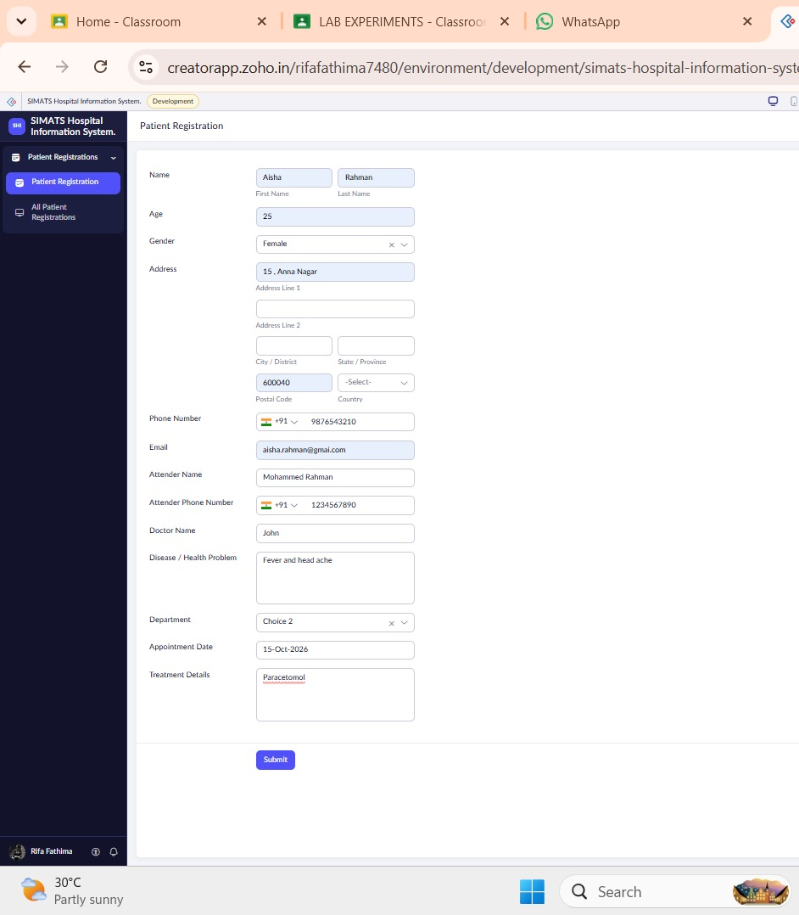
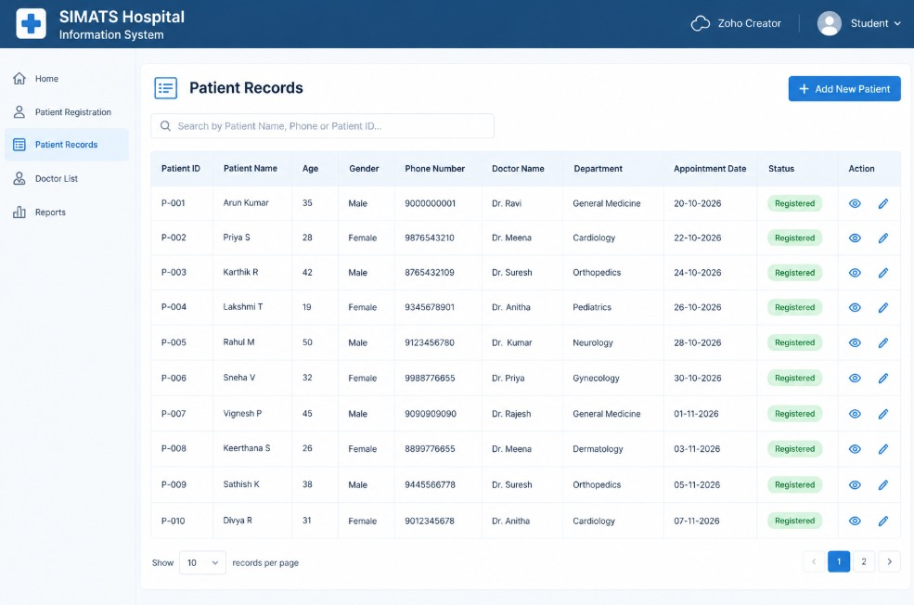
Result: The Hospital Information System was created successfully using Zoho Creator to store and manage patient and hospital information through a cloud-based application.

10. Student Information System Using C Program
Aim: To develop a simple student information application using a cloud service platform to display student details, courses, grades, attendance reports, progress reports and semester mark sheets.
Procedure:
- Create a cloud application using Zoho Creator.
- Create a Student Information form with student name, register number, address, phone number and age.
- Add fields for courses and grades.
- Create separate forms for attendance reports, progress reports and semester mark sheets.
- Enter student details and submit the forms.
- Use a C compiler separately to write and execute a C program that displays student information, if C execution is required.
- View the stored information through the cloud application's reports.
Input & Output:
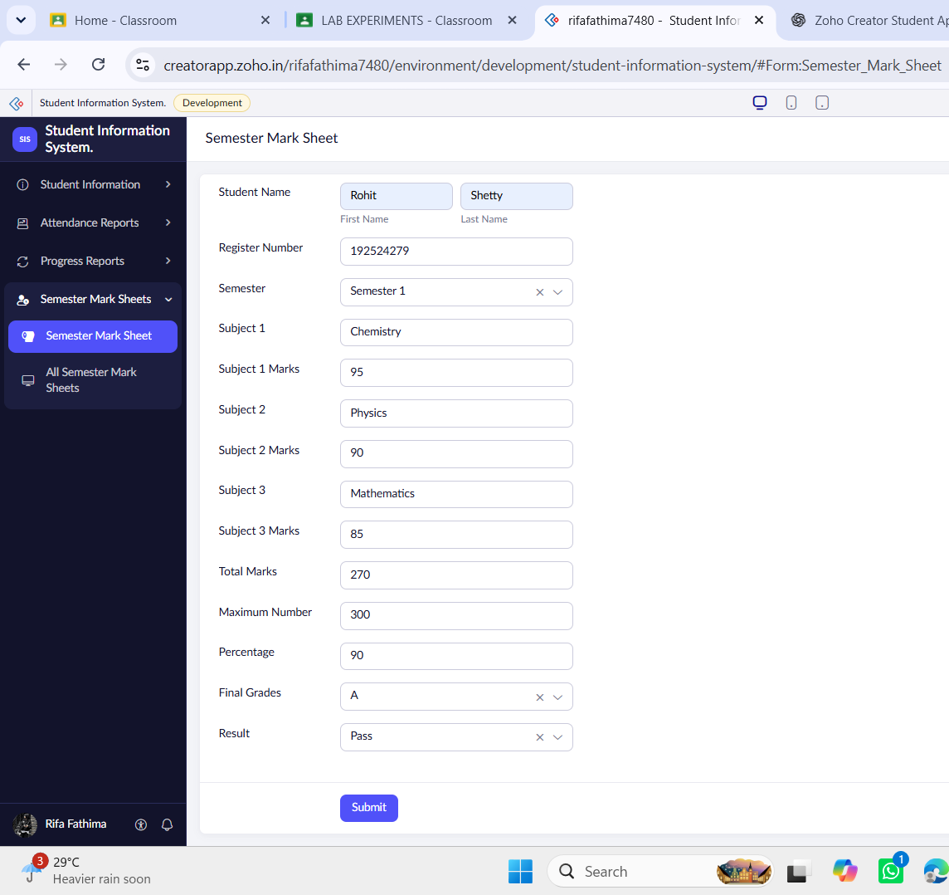
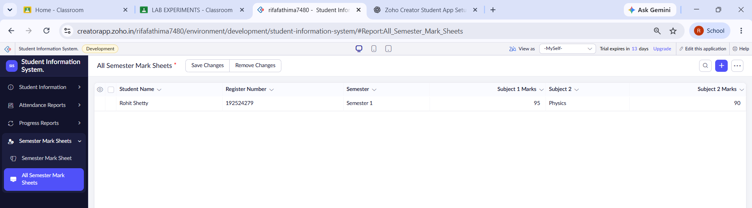
Result: The Student Information System was created using Zoho Creator to manage student details, academic performance, attendance and semester marks, demonstrating the basic features of SaaS.
Note: Zoho Creator does not directly compile and execute C programs. The C program must be run separately using a C compiler.

11. Online Supermarket Application
Aim: To develop a simple cloud-based Online Supermarket application using Zoho Creator to manage customer details, supermarket items, item classifications, quantities and prices.
Procedure:
- Create a new application in Zoho Creator named Online Supermarket.
- Create a Customer Order form with customer name, address, phone number, email, item name, quantity and price.
- Create an Item Classification form with item name, category, brand name, price, available quantity, expiry date and availability status.
- Enter sample supermarket item details and customer orders.
- Submit the forms and view the saved records in the reports.
- Verify the customer order and item classification details.
Input & Output:
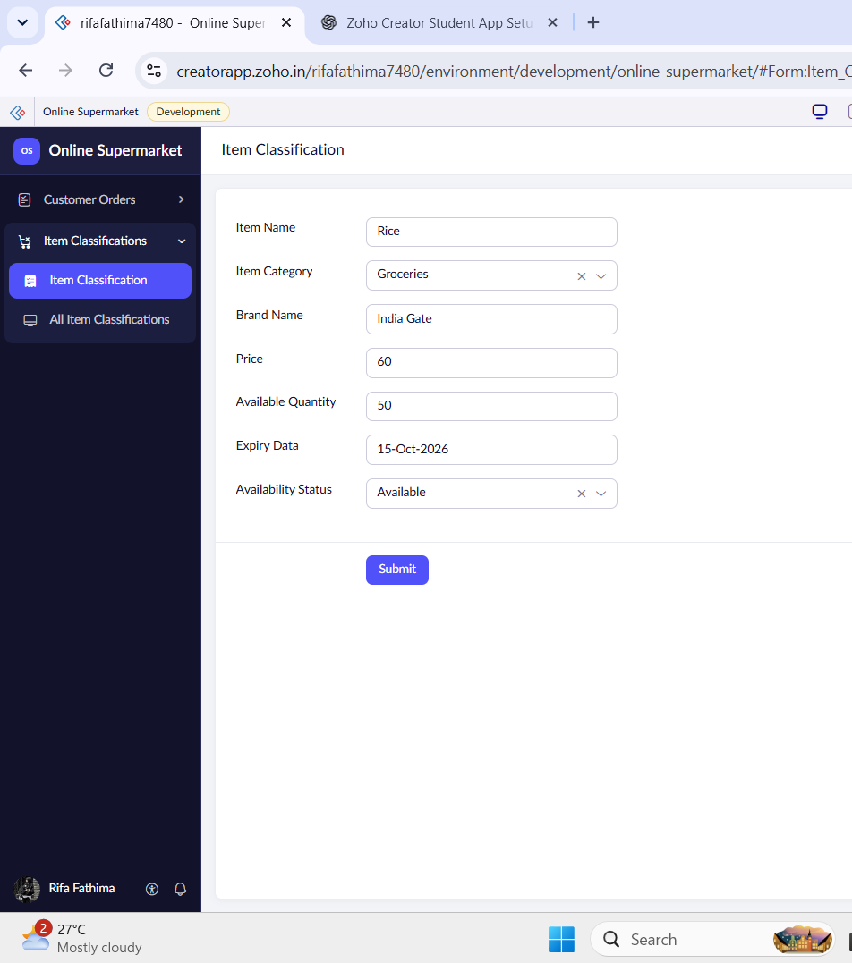
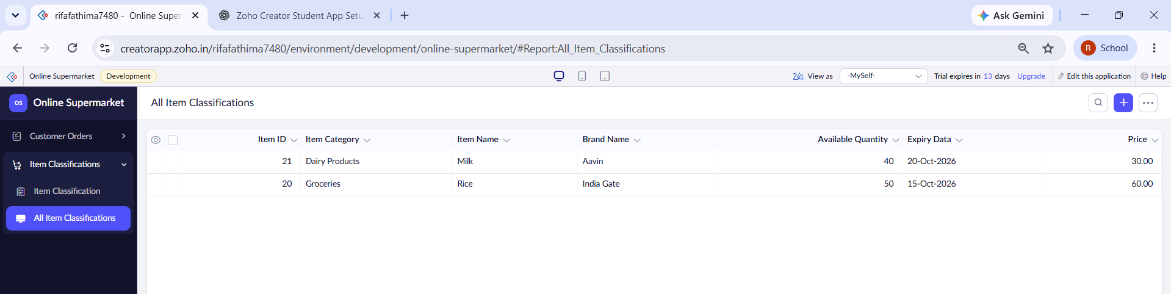
Result: The Online Supermarket application was created successfully using Zoho Creator to manage customer orders, product classifications, prices and stock details through a cloud-based SaaS application.

